HILLCREST SURGERY FRIDGE TEMPERATURE EXCURSION
Temperature Excursion (Out-of-Range Response)
If temperature falls outside +2°C to +8°C:
PLEASE FOLLOW NHS ENGLAND COLD CHAIN TOOLKIT
1. Do not use affected stock
2. Keep fridge closed where possible
3. Record the temperature and details of the incident
4. Inform the Practice Nurse or Practice Manager immediately
5. Check data logger for duration of excursion
6. Transfer stock to an alternative fridge if required
7. Label stock as “Do Not Use – Temperature Excursion” add date and time
8. Seek guidance before using or discarding stock (e.g., manufacturer or local policy, NHS England, Immform)
9. Document incident and actions taken

Please may I reinforce that information received from manufacturers does change according to their research so can only be used for the breach at the time, rather than general guidance unless its noted on the SMP.

Vaccine Manufacturer Telephone Number Advice
Infanrix Hexa
(DTaP,IPV,Hib/HepB) GlaxoSmithKline UK 0800 221 441 On Label
Stable for 72 hours at a max temp of 25
Rotarix (Rotavirus) GlaxoSmithKline UK 0800 221 441 Off label
72 hours, max temp 25
Menitorix (Hib/MenC) GlaxoSmithKline UK 0800 221 441 Off label
168 hours, max temp 37
Priorix (MMR) GlaxoSmithKline UK 0800 221 441 Off label
72 hours, max temp 25
Boostrix - IPV GlaxoSmithKline UK 0800 221 441 Off label
Stable for 8 hours at 21°C
Bexsero (Men B) GlaxoSmithKline UK 0800 221 441 Off label
8 hours, max temp 21
Menveo (MenACWY) GlaxoSmithKline UK 0800 221 441 Off label
No data

HOW TO DOWNLOAD THE DATA LOGGER
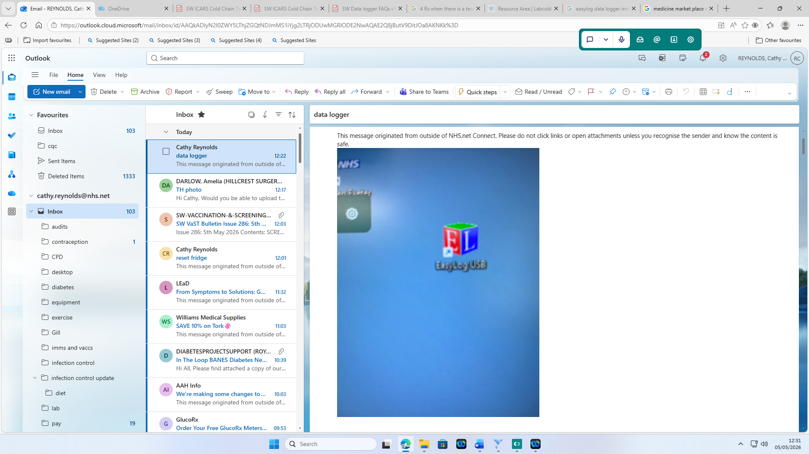

Download the Easy log App
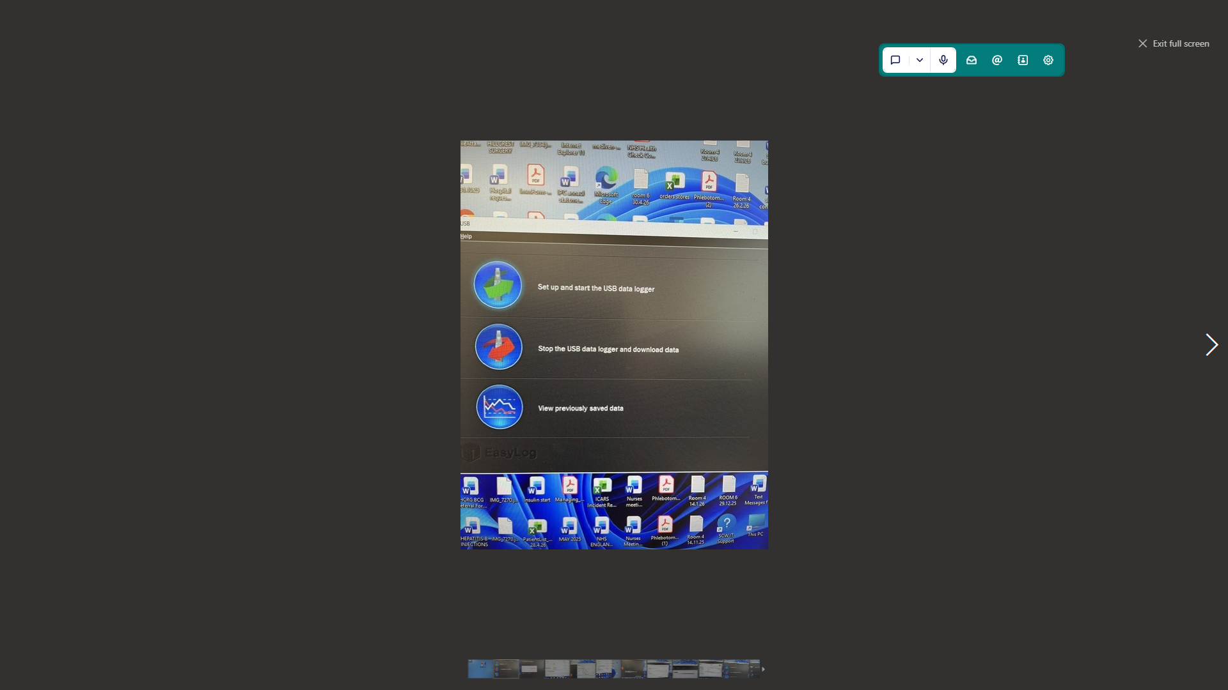

Go into Stop using data logger and download data
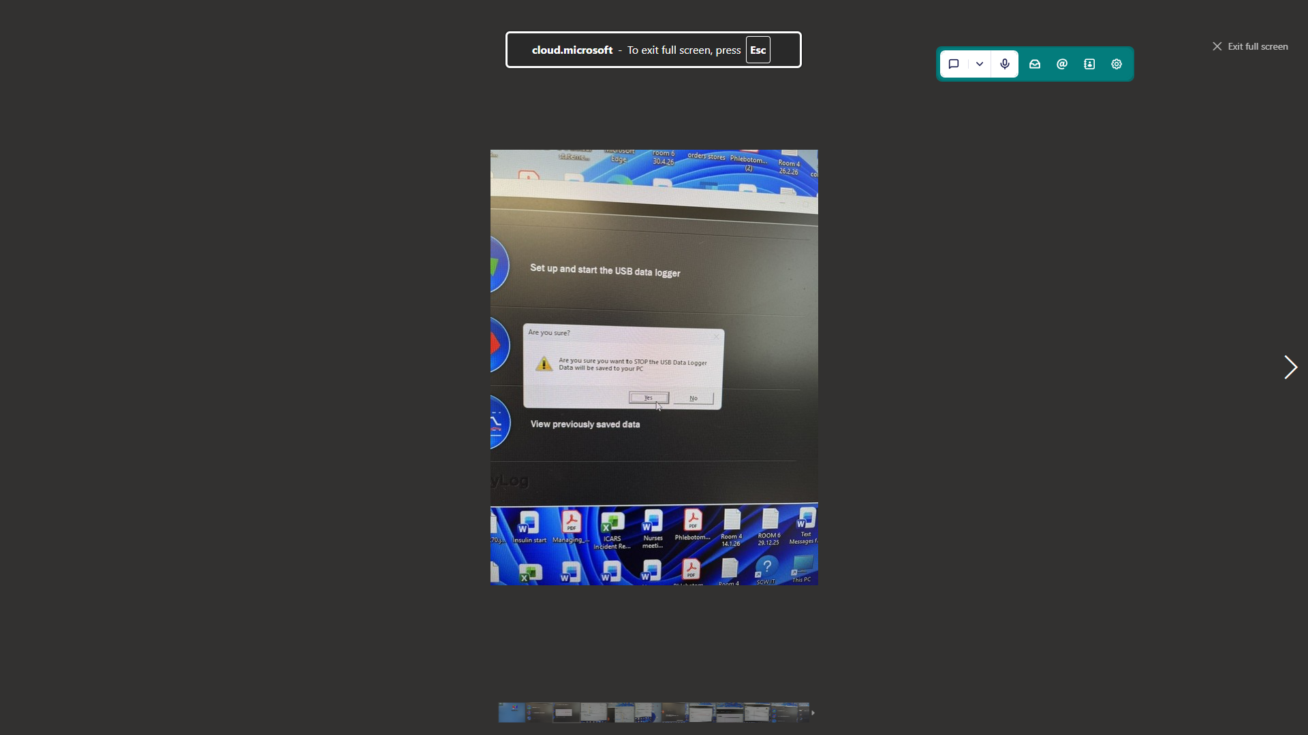

Yes you want to stop the data logger
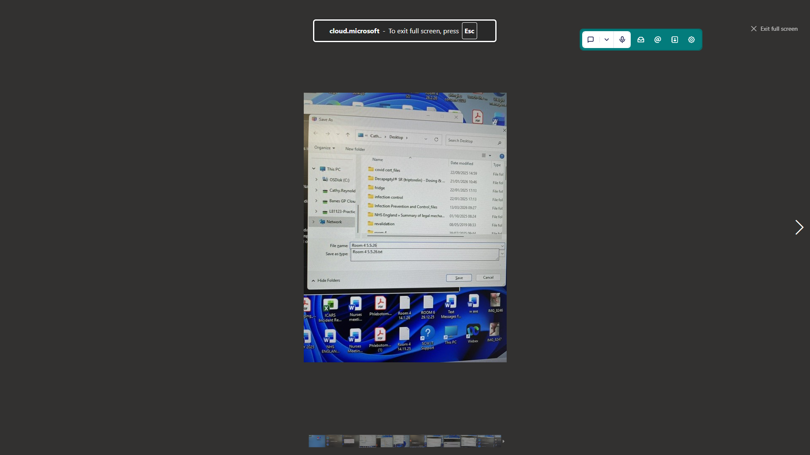

Save to desktop with the date the room number will be displayed.

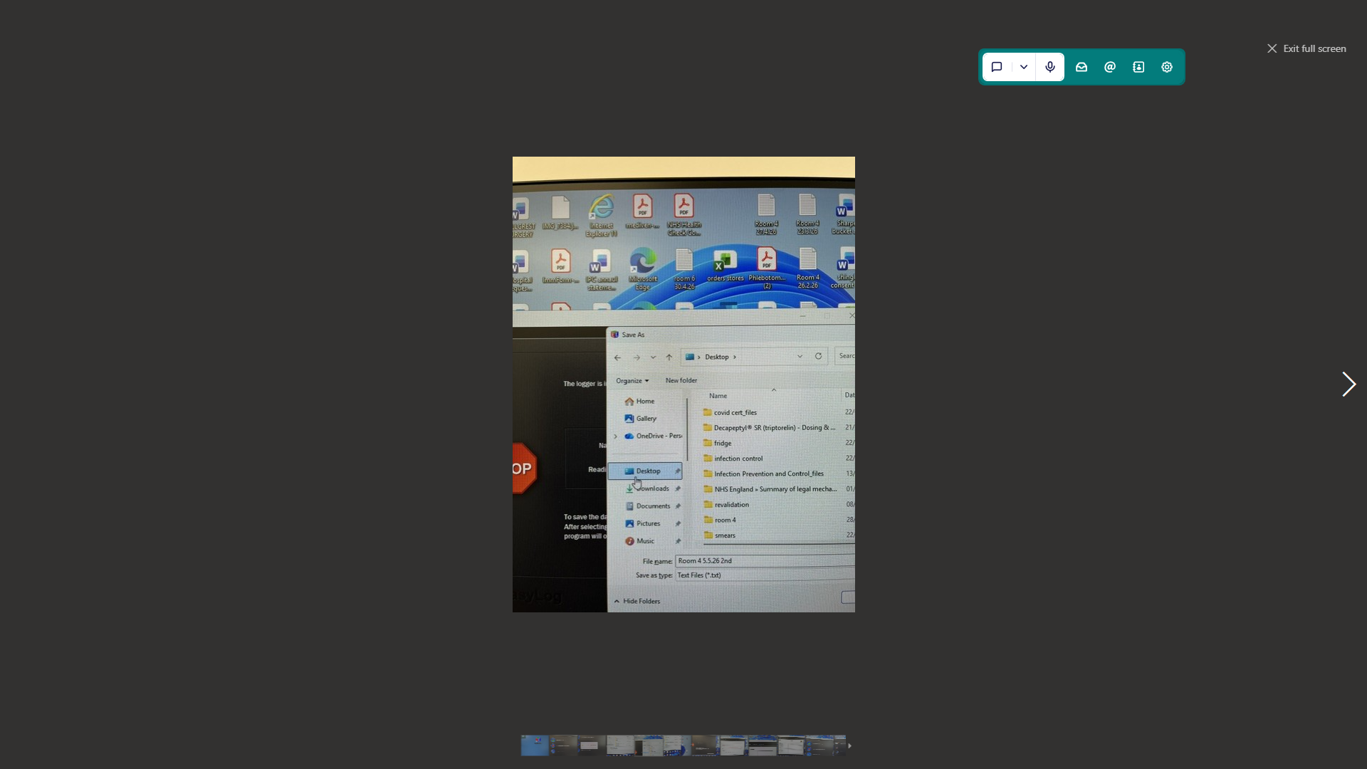
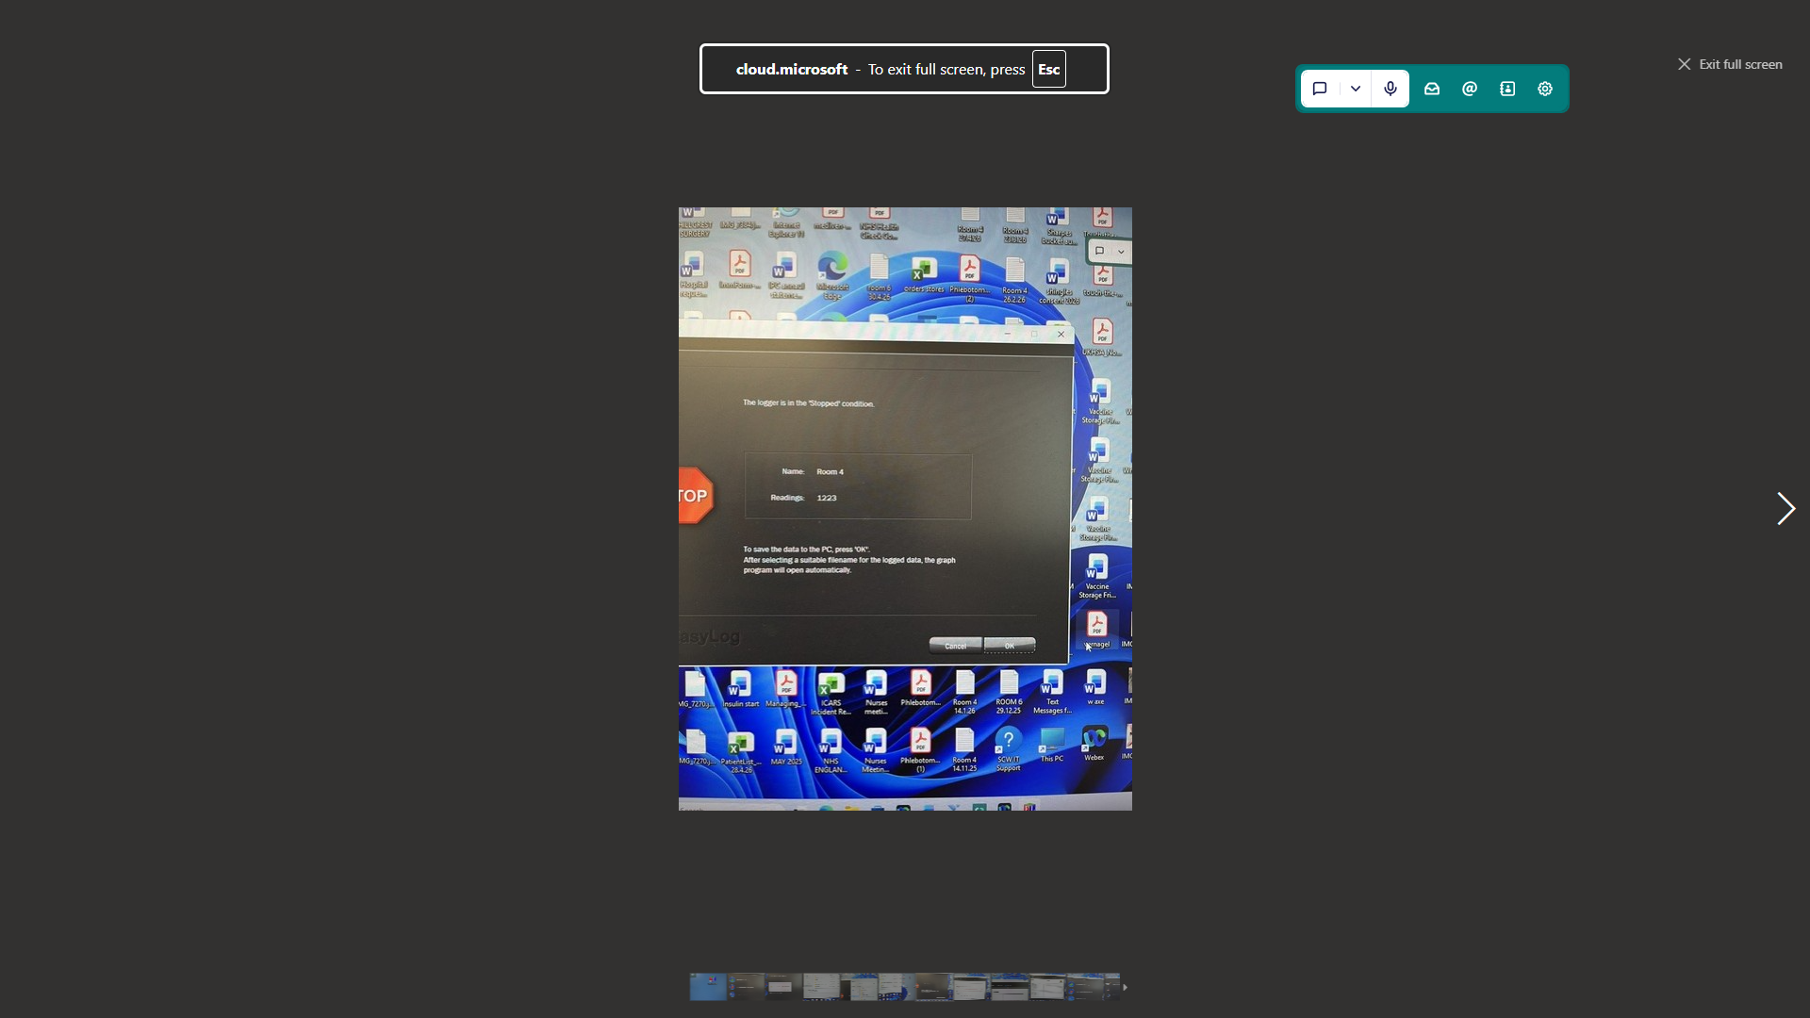
The logger is in the stopped position press ok
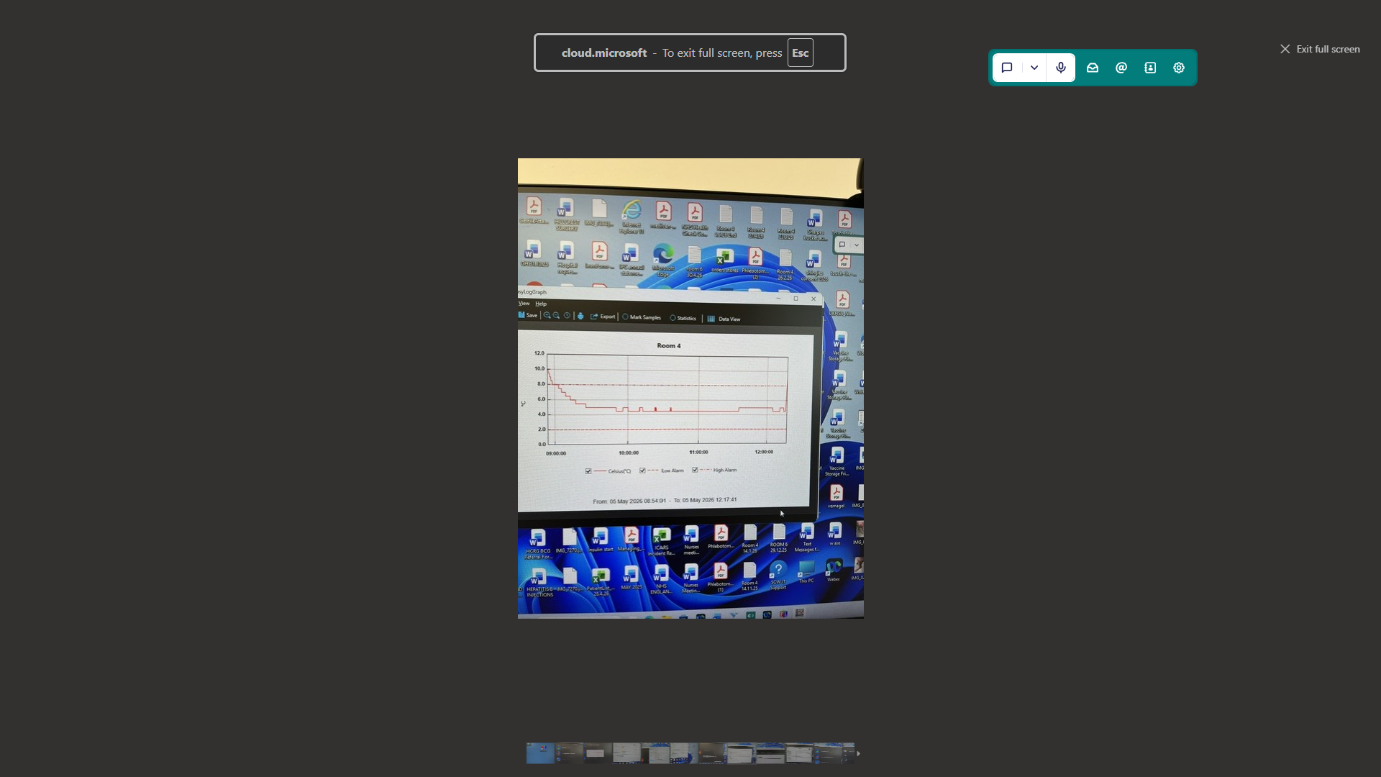

Look and see if the graph goes above or below the top and bottom line take a screenshot
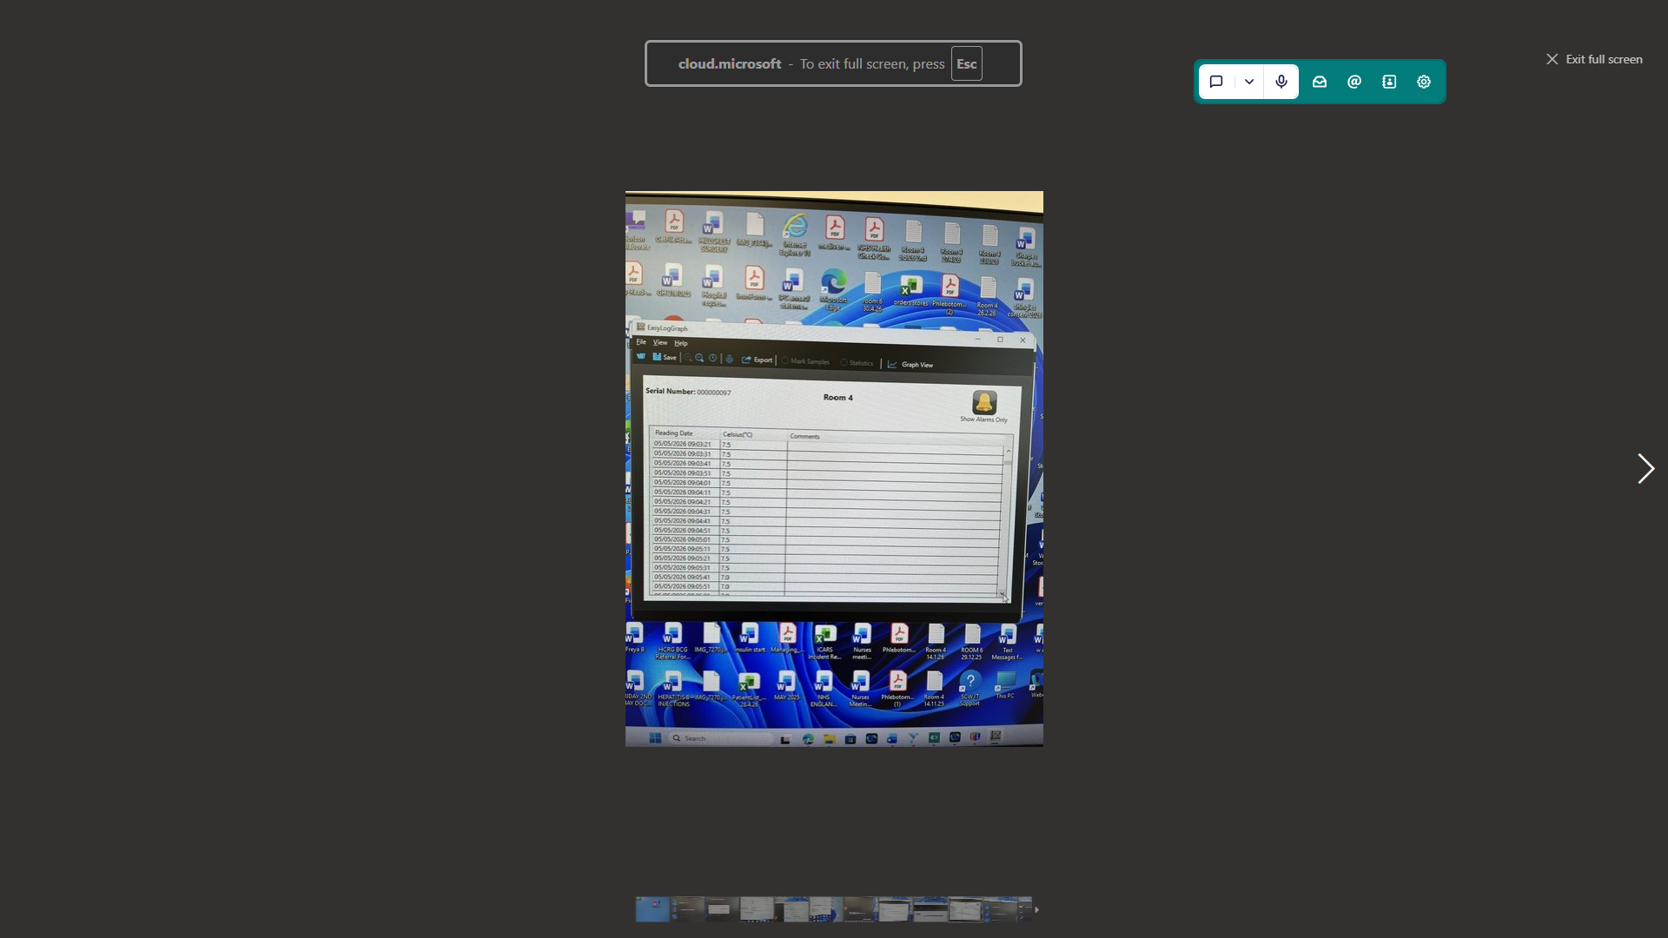
Go into data view, screenshot any red areas or blue which show hot of cold episodes and how long they lasted.
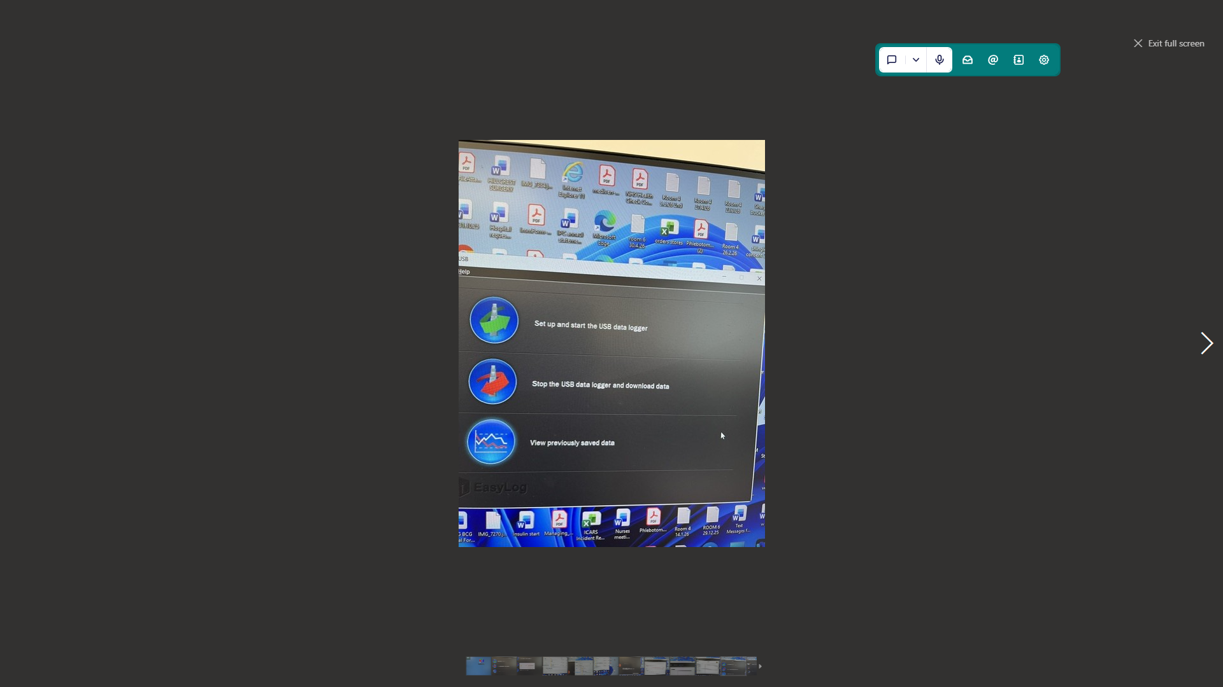

Press set up and start using data logger
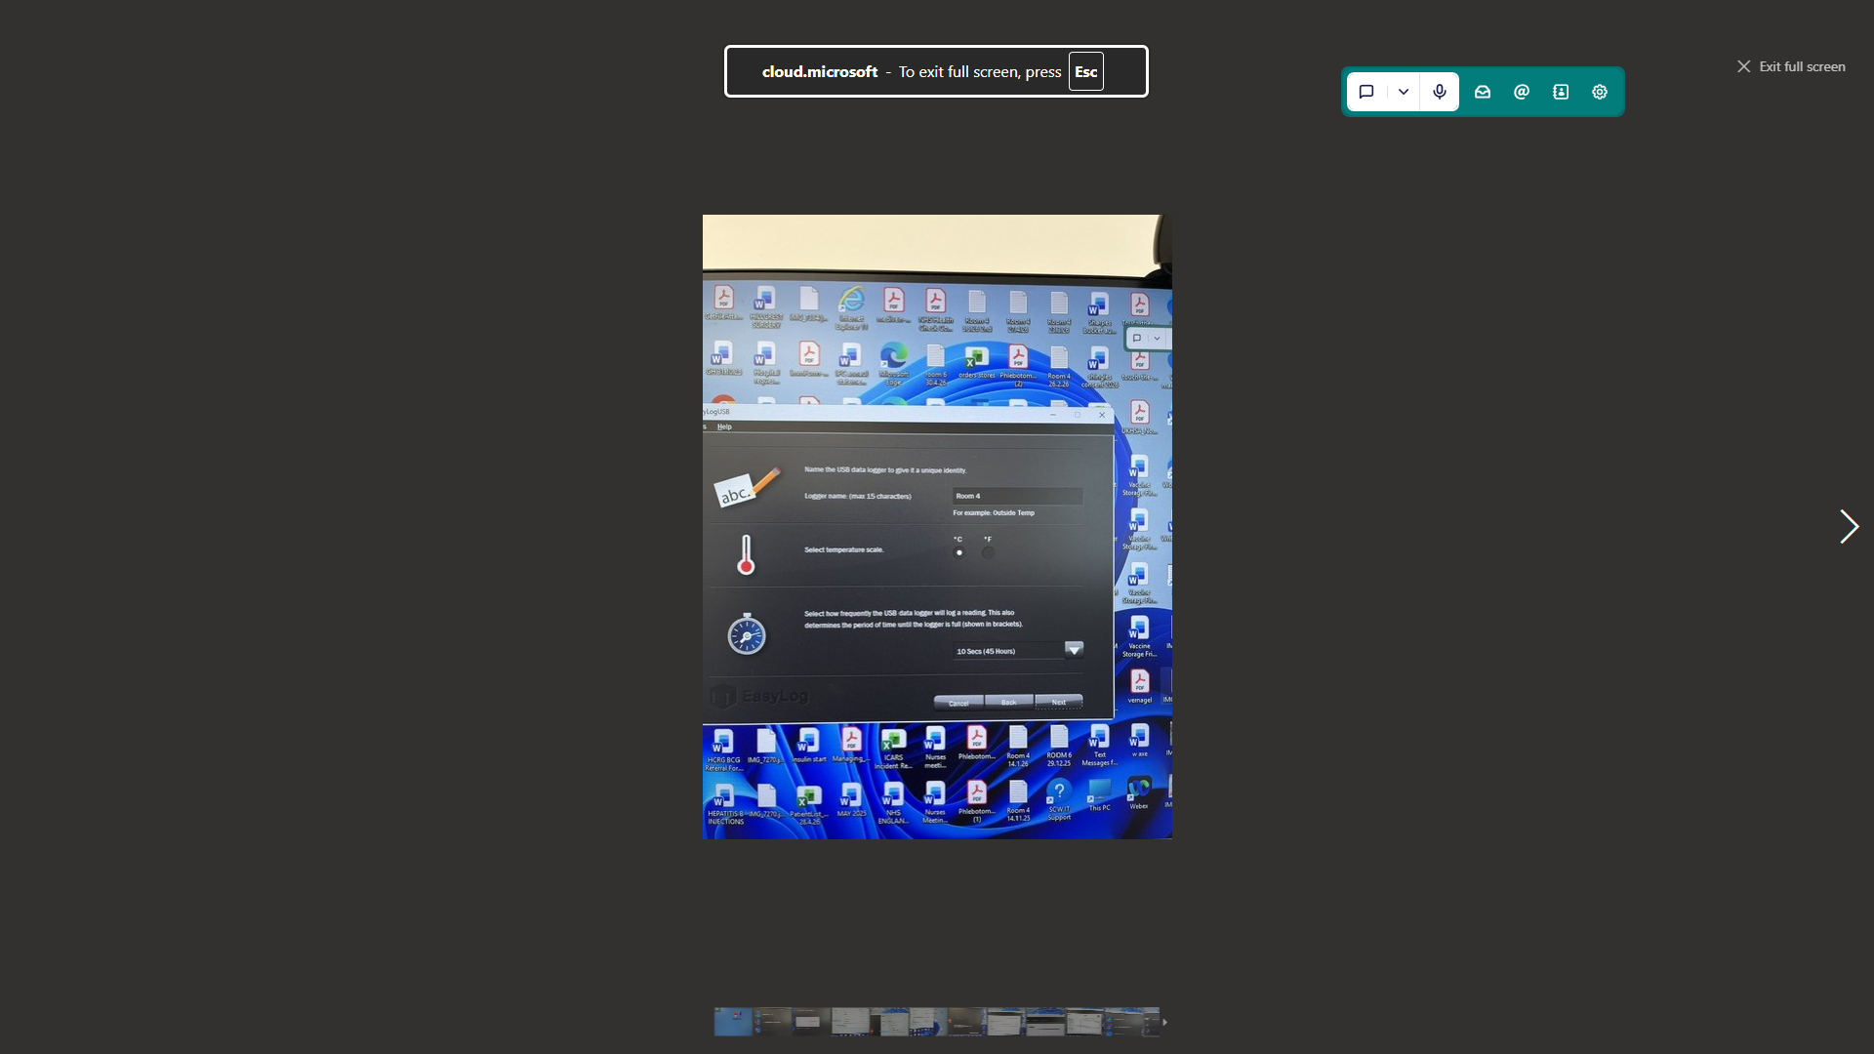

Keep pressing next
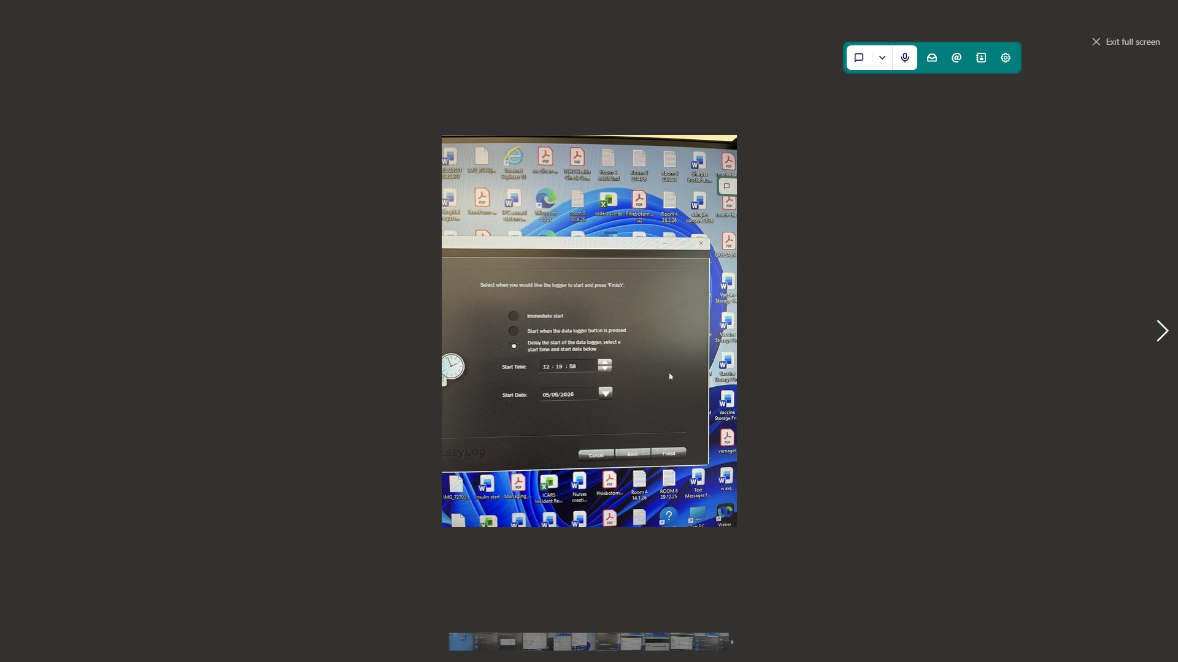

Press delay start and change the start time for 3 minutes

Remove the USB, replace the plastic case and put the data logger back into the fridge.

HOW TO TAKE AND RESET THE LABCOLD TEMPERATURE

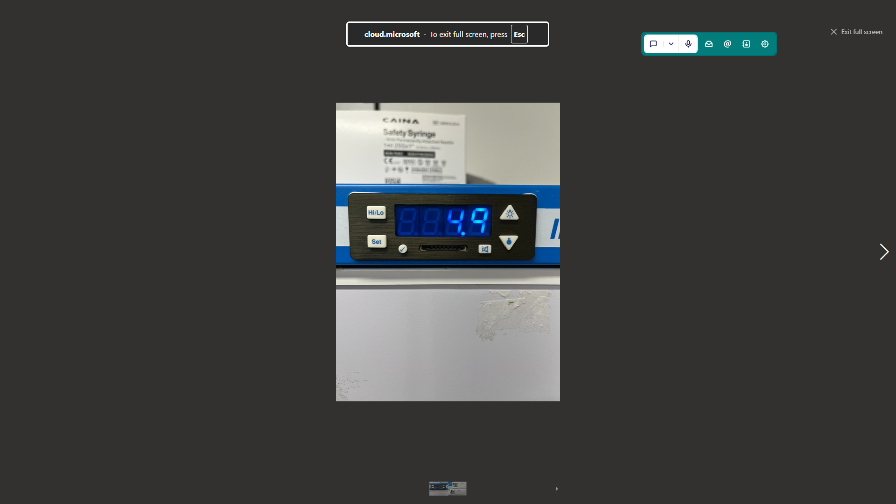

PRESS HIGH/LOW AND RECORD ALL 3 TEMPERATURES THE ONE ON DISPLAY AS SHOWN IS THE CURRENT TEMPERATURE
Press and hold high/low until it flashes it will sound with a continuous beep, Then press tick to reset the temperature.
Press high/low again all 3 temperatures should be exactly the same to show you have reset it successfully, if it is not, then repeat the reset process.

You may have to hold high/low and tick at the same time.

With the fridge in room 6 it will show CFN then tick

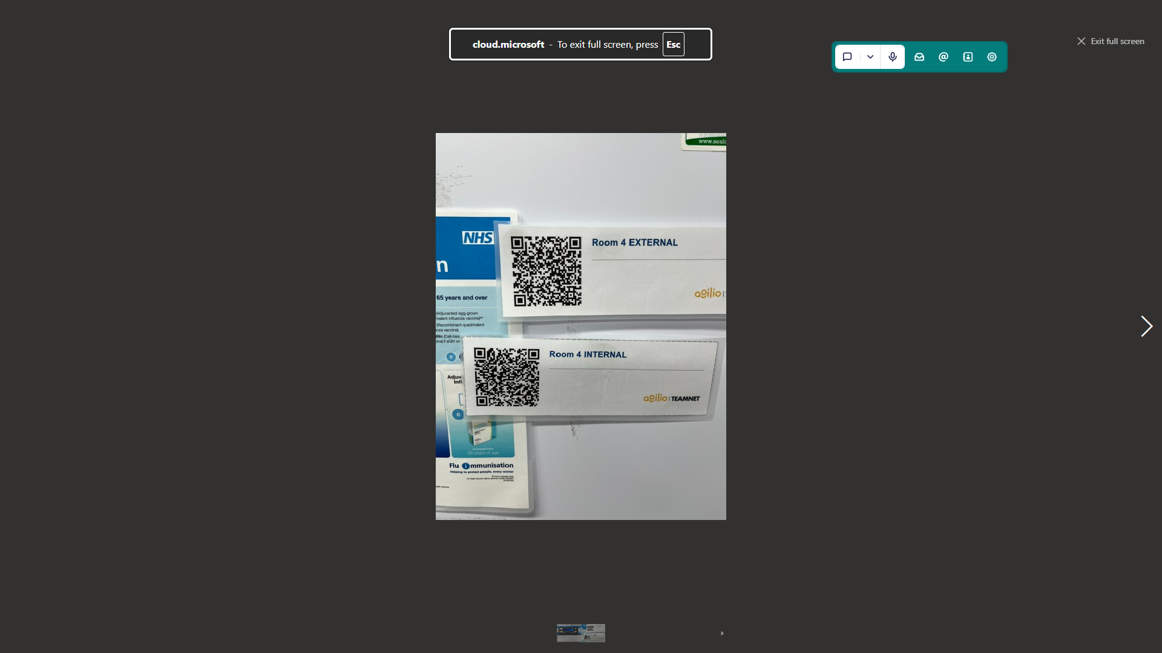

SCAN THE QR CODE AND SAVE THE TEMPERATURE TO THE CORRECT FRIDGE ON TEAMNET

https://teamnet.clarity.co.uk/l81123/Files/DataItemDownload/e6ab178d-59c8-4786-8f1a-acae00f96666/42b33d7e-2dbb-4d9a-8caa-af8e00e380b6
Aglio teamnet, How to record temperature and scan QR code.

https://teamnet.clarity.co.uk/l81123/Files/DataItemDownload/635236fe-0c7a-429a-8076-b01f00af177a/4cd44d46-fa5c-4992-aa64-b1cc00b3af4
recording internal fridge temperature and resetting, on Teamnet, Library

3. Definition
A cold chain breach occurs when vaccines are exposed to temperatures outside the recommended range of +2°C to +8°C.
Immediate Actions
Steps to follow in temperature breech
PLEASE FOLLOW NHS ENGLAND COLD CHAIN TOOLKIT

THE KEY STEPS ARE
1- Inform Cathy Reynolds- Lead
2- Hannah Holland- Deputy
3- Beth Ashman- 3rd deputy
4- Partners 4th Deputy
In that order until you have passed on the temperature excursion

• Quarantine all affected vaccines immediately
• Label clearly: “DO NOT USE”
. Move vaccines to another fridge
• Maintain cold chain conditions (+2°C to +8°C) while awaiting guidance
• Do not discard vaccines until a full assessment is completed
________________________________________
5.2 Incident Reporting
• Complete an internal incident form
• Record:
o Date and time of breach
o Temperature range and duration
o Possible cause (e.g., data logger not reset, alarm failure)
3 Risk Assessment (Clinical Decision)
• Contact regional immunisation support team NHS England- they will advise you and triage
• Review:
o Manufacturer stability data – see NHS England toolkit, contact each manufacturer, log the specifics of the temperature excursion, they will let you now if the vaccines can be used.
o National guidance
Vaccines may still be used:
• On-label, or
• Off-label under a PGD where supported by evidence
Reset fridge temperature, go back hourly to check if the fridge temperature has stayed within range. Until the lead or deputy is happy that the fridge is working and stable
________________________________________
5.4 Decision-Making
• Final decision rests with the GP practice
• Avoid unnecessary wastage where safe use is supported
Disposal (if required)
• Dispose only if confirmed unsuitable
• Record cost of wastage – with Immform and NHS England
• Follow clinical waste procedures – put filled vaccines in blue bin (do not empty the contents), plastic and cardboard to be recycled.
. Temperature Excursion (Out-of-Range Response)
If temperature falls outside +2°C to +8°C:
1. Do not use affected stock
2. Keep fridge closed where possible
3. Record the temperature and details of the incident
4. Inform the Practice Nurse or Practice Manager immediately
5. Check data logger for duration of excursion
6. Transfer stock to an alternative fridge if required
7. Label stock as “Do Not Use – Temperature Excursion”
8. Seek guidance before using or discarding stock (e.g., manufacturer or local policy)
9. Document incident and actions taken

https://teamnet.clarity.co.uk/l81123/Files/DataItemDownload/bd217870-d22c-4f39-bb3d-b01f00b3d3ef/2875a222-1a3d-4494-86a3-b43d00ac30f4
vaccine storage failure table
): After a power loss, the unit may ask for the date and time (Year Y \(\rightarrow \) Month N \(\rightarrow \) Day D \(\rightarrow \) Hour H \(\rightarrow \) Minute N). Use arrows and the tick button to set these.Alarm Muting: If the temperature is out of range, press the mute/bell icon to silence it for 15 minutes. The alarm only turns off completely when the

Data Logger FAQs 2025
NHS England
South West Vaccination & Screening Team

This guidance is correct as at 20 August 2025
Please contact the South West Vaccination & Screening Team at england@swvast@nhs.net if you have any queries about this document.
Please contact the South West Immunisation Clinical Advice and Response Service (ICARS) at england.swicars@nhs.net with all cold chain events.
Version 1, 20 August 2025

What is a data logger, and why is it used in fridges?
A data logger is an electronic device that records temperature measurements as short intervals. In fridges, it's used to monitor and verify that temperatures remain within safe limits for vaccine and medicines storage. It provides reliable documentation for audits, compliance, and quality control. Data loggers can also be integrated onto a digital monitoring system to allow monitoring of multiple areas remotely via a web-based browser.

Where should I place a data logger inside the fridge?
To ensure accurate and representative readings:
• Place the logger in the centre of the fridge, away from vents or the door.
• Avoid placing it directly next to the cooling element or fan.
• Position it next to the vaccines to reflect the temperature they are exposed to.
• Avoid areas prone to temperature spikes (like near the door or light).
• Read product literature for specific recommendations related to the brand of logger.

How often should data loggers be calibrated?
Sensors which are not routinely calibrated can drift over time and display false temperature readings.
Calibration should be carried out annually to an accuracy of +/- 0.5°C by a specialist testing service with UKAS accreditation. UKAS is the National
Accreditation Body for organisations that provide calibration services. This website can be used to check for accreditation: UKAS CertCheck - Verify Accredited
Management System Certificates

What temperature range should a fridge maintain for compliance?
Vaccines should be stored according to the manufacturers summary of product characteristics (SPC), usually at +2°C to +8°C. Good practice is to aim for the +5°C midpoint.
Always refer to the specific product literature for each product being stored.

Are there any required features for data loggers?
Key features required from a standalone data logger include:
• compliant with BS EN12830 standards
• UKCA / CE marked
• a display which allows for reading of current temperature, indication of active logging, battery status and alarm indicator
• user programmable logging frequency with large memory capacity, e.g. able to log temperature at 5-minute intervals for 6 months or more
• robust construction, splash resistant, and designed for operation at temperatures in which it used
• evidence of calibration supplied with the logger

What should I look for in a good data logger for fridges?
Key features to consider:
• Alarm settings for temperature breaches.
• Easy data access (USB, Bluetooth, or Cloud).
• Battery life and memory capacity.
- A system must be in place to either periodically replace the battery or check the battery level indicator.
• Compliance with UK/EU standards.
• Check for ICB recommended data loggers in your area.
Further information:
SPS - Using temperature sensors in medicines storage areas: Using temperature sensors in medicines storage areas – SPS - Specialist Pharmacy Service – The first stop for professional medicines advice

Green Book, Chapter 3 – Storage, distribution and disposal of vaccines:
Green_Book_Chapter_3_v3_0W.pdf

