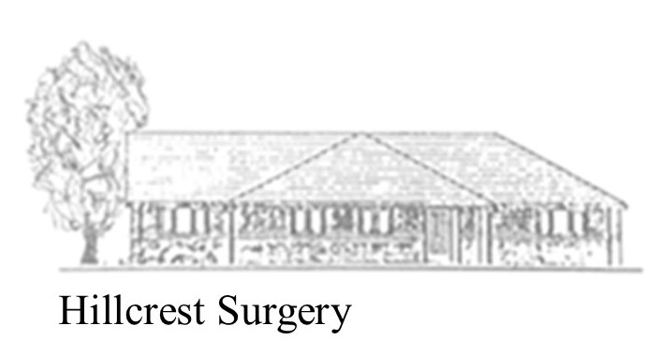
Dr Andrew Nesbit (GP Partner) | MB Bs DRCOG MRCGP (London 1997)
Dr Victoria Collinson (GP Partner) | ChB (Hons) MRCGP (Bristol 2000)
Dr P Barton (GP Partner) | ChB DRCOG MRCGP

Welcome to Hillcrest Surgery

A Quick Guide for New Patients
We're delighted to welcome you to Hillcrest Surgery. This leaflet explains how to access our services and get the care you need.

📅 Making an Appointment
There are several ways to book an appointment:
✅ By phone
- Call 01761 434469
- If you need an urgent same-day appointment, please phone from 8:00am.
✅ Online
- Use SystmOnline or the NHS App to book, change or cancel appointments.
- You can also submit routine or non-urgent medical requests online using SystmConnect.
✅ In person
- Visit our reception team during opening hours.

We may offer you an appointment with:
- A GP
- Practice Nurse
- Clinical Pharmacist
- Another suitable healthcare professional
Our reception team are trained to direct you to the most appropriate clinician for your needs.

💊 Pharmacy First
Did you know you may not need to see a GP?
Your local pharmacy can now assess and treat several common conditions without you needing a GP appointment.
These include:
- Sore throat
- Earache
- Sinusitis
- Infected insect bites
- Impetigo
- Shingles
- Urinary tract infections (women)
Our reception team can refer you directly to a participating pharmacy, where you may receive NHS treatment and medication if appropriate.

🕒 Opening Hours
Day | Opening Hours
Monday | 8:00am – 6:00pm
Tuesday | 8:00am – 6:00pm
Wednesday | 8:00am – 6:00pm
Thursday | 8:00am – 6:00pm
Friday | 8:00am – 6:00pm
Saturday | Closed
Sunday | Closed
We also offer some early morning, evening and Saturday appointments through our Enhanced Access service. Please ask Reception for details.

☎️ Contact Us
Hillcrest Surgery
Wellow Lane
Peasedown St John
Bath
BA2 8JQ
Telephone: 01761 434469
For routine enquiries, you can:
- Telephone Reception
- Email bswicb.reception.hillcrest@nhs.net (do not email about medically urgent problems)
- Visit Reception in person
If possible, please telephone after 11:00am for non-urgent enquiries, as mornings are our busiest time.

🚨 When We Are Closed
If you need medical help when the surgery is closed:
Visit a local pharmacy
NHS 111
- Visit 111.nhs.uk
- Or call 111
For life-threatening emergencies always call 999.

📱 Helpful Online Services
You can use the NHS App or SystmOnline to:
- Book appointments
- Cancel appointments
- Order repeat prescriptions
- View parts of your medical record

We're Here to Help
Our aim is to provide the right care, at the right time, with the right healthcare professional.
Welcome to Hillcrest Surgery—we look forward to caring for you.

