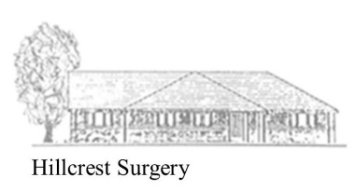

Hillcrest Surgery

Statement of Purpose

About our business
- Hillcrest Surgery
- GP Partnership
- Hillcrest Surgery, Wellow Lane, Peasedown St John, Bath, BA2 8JQ
- Partners;
  - Dr A Nesbit
  - Dr V Collinson
  - Dr P Barton

Our Mission
We are dedicated to enhancing the quality of peoples lives through the provision of accessible, high quality and personalised care.

Our values

- Care and Compassion;
  - Our patients are at the heart of what we do.
  - We aim to provide the best possible outcomes for our patients in a welcoming environment.
  - We treat people consistently but remain patient focused and value each person as an individual.
  - We celebrate differences and provide equal opportunities

- Respect and Trust;
  - Our team are approachable and supportive to our service users, their families and carers, and each other.
  - We are accountable and transparent to our service users.

- Clinical excellence;
  - We will continue to invest in staff training and development through the greater understanding of conditions and treatments, and proactively training staff.

We hope to maintain a very high level of professionalism and inspire trust in our services users and extended community.

Places where we provide services
- We are a rural GP Practice just outside of Bath.
- We serve approximately 6000 people
- We provide services such as diagnostics and screening, family planning, maternity care, minor surgical procedures, and treatment of disease, disorder or injury. As well as chronic health management and referral to other services as required.

Our registered manager
- Dr Peter Barton
- Bswicb.reception.hillcrest@nhs.net

